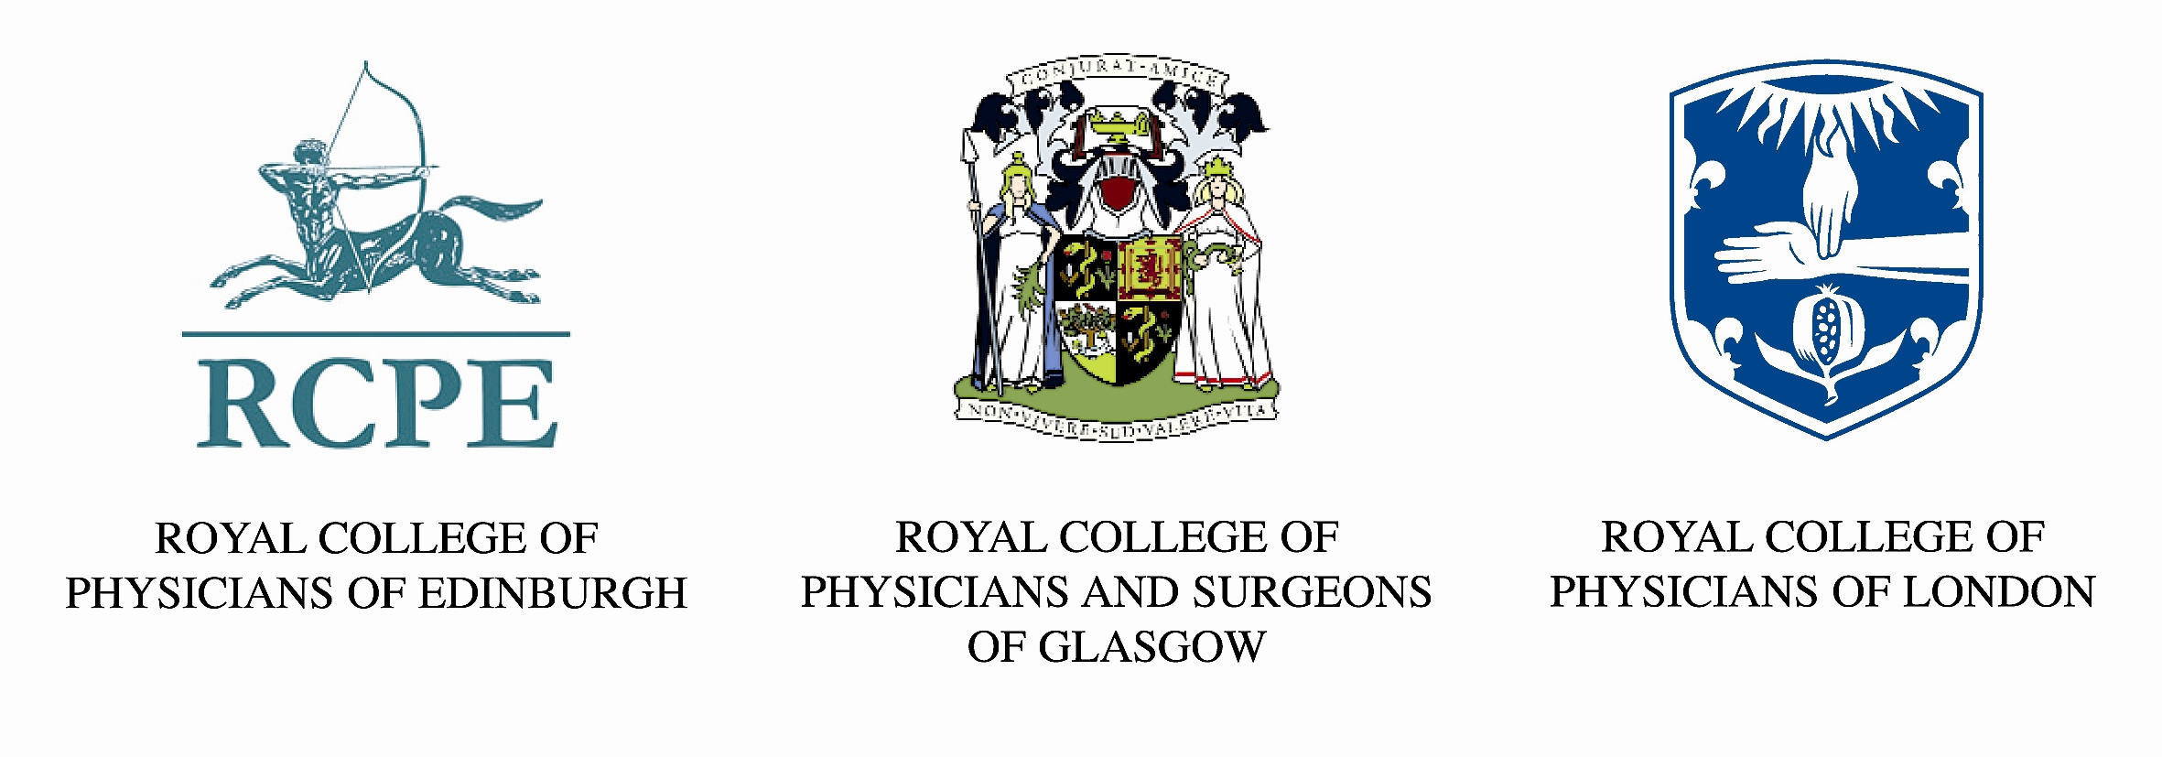

INDIVIDUAL VERIFICATION REQUESTS

- All Sections must be completed in full. In completing this form you give your consent to confirm your MRCP(UK) or SCE qualification to an organisation or third party.

RCP London
RCP Edinburgh
SECTION 1 – Request for information
Please see Notes Section 1 for information and advice on completing this form.

RCP&S Glasgow
Yes
No

DOCTOR’S FULL NAME (As appears on MRCP(UK) / SCE Certificate)

FAMILY NAME

CURRENT NAME (If different)

QUALIFICATION

RCP CODE NUMBER
YEAR OBTAINED
ADDRESS
DATE OF BIRTH (dd/MMM/YYYY)
e.g 12/06/1987 or 12 June 1987
If a Collegiate Member, which College do you pay your subscription fee? (Please tick appropriate box below)
Are you a subscriber to Collegiate Membership?

GMC NUMBER (If known)

SECTION 2 – Address where verification letter should be sent
CONTACT FULL NAME
ORGANISATION
REFERENCE NUMBER (If applicable)

Yes
No
Please complete this section if you wish the verification letter to be sent to a different address to that given in Section 1.

FULL ADDRESS
POST CODE/ZIP CODE
CITY
FAX
EMAIL ADDRESS
TELEPHONE
The fee for a verification request is £10.00 GBP (except for Collegiate members who are exempt), and can be paid by credit card http://www.mrcpuk.org/SiteCollectionDocuments/Card%20Payment%20Form_231008.pdf or by cheque/banker's draft.

Please post or fax the completed form and the completed credit card payment form/cheque/banker’s draft (if applicable) to:

Verifications Section
Examinations Department
Royal College of Physicians
11 St Andrews Place
Regent's Park
LONDON
NW1 4LE

Fax number: 0207 486 8401

If submitting a cheque or bankers draft, please write your full name and RCP Code number details on the reverse of the cheque or draft. Please allow 28 days for the completed request. Verification confirmations will be posted to requestors on headed notepaper.
PAYMENT FORM WITH CC OR CHEQUE ATTACHED (If you are not a collegiate member or if the request for verification is being made through a third party)

NOTES SECTION 1 – Request for Doctor information

In Section 1 please enter your details in full.

- Full Family Name: Please enter the your full name as appears on their Primary Medical qualification/MRCP(UK) certificate or Specialty Certificate Examination diploma.

- Date of Birth: Please enter your date of birth details. This is an essential requirement

RCP Code Number (if known): please enter your Royal College of Physicians code number.

- Qualification and Year obtained: Please enter details of the qualification you would like verified – (MRCP(UK) or SCE). Please add year qualification was obtained (if known).

GMC number (if known): Please enter your GMC registration number.

- Subscriber to Collegiate membership:

If you are a doctor who is a Collegiate Membership subscriber, please tick the yes box and give details of the College to which you pay your Collegiate Member subscription. Please submit your request form by post or email mrcpverifications@mrcpuk.org

If you are a doctor who does not pay a Collegiate Membership subscription or your Collegiate Membership subscription has expired you are required to pay a verification fee of £10.00 GBP and submit payment with this request form by post or by fax.

NOTES SECTION 2 – Address to which the verification letter should be sent

- Payment Section: Please enter sum of payment enclosed in GBP sterling. Payment must be submitted with every verification request submitted by any doctor who does not currently subscribe to Collegiate Membership with any of the Royal Colleges of Physicians and can be made by credit card (see credit card payment form), cheque or draft. The verification fee is £10.00 per doctor per request.

- When paying by cheque or bankers draft, please ensure that your full name and RCP Code number details are written on the reverse of the cheque or draft.

