Directions to the Iraqi Cultural Centre
Threshold and Union House
65-69 Shepherds Bush Green
London W12 8TX

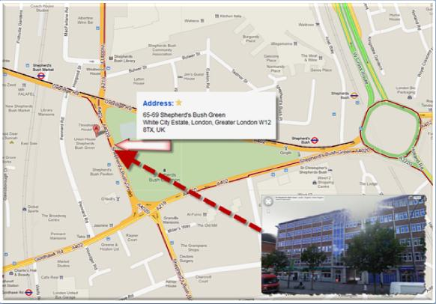

By Car:

The Iraqi Cultural Centre is just 3-min walk from Westfield Shopping Centre where is there a large car park available.

By Underground:

Central Line: Shepherd's Bush
Hammersmith & City: Wood Lane and Shepherd's Bush Market

